**CAPSTONE PROJECT REPORT**

(Project Term January-May 2021)

## (Role Of Infomation Technology In Tourism)

Submitted by

**Deva Charan Kumar Reddy Registration Number :11705783**

**Valeti Naveen Registration Number :11711063**

**Venkata sudheer Registration Number :11705334**

**Venkata Sai Manoj Registration Number :11705320**

**Project Group Number ………….**

**Course Code :CSE455**

Under the Guidance of

**(Krishan Bansal)**

# School of Computer Science and Engineering



**PAC Form**

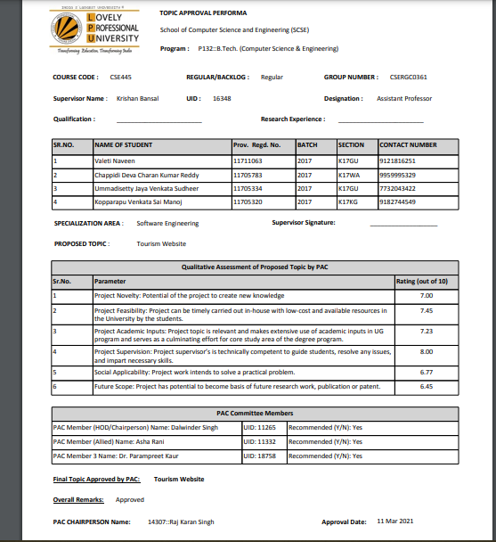

**-----**

**DECLARATION**

We hereby declare that the project work entitled “Role of Infomation Technology in Tourism” is an authentic record of our own work carried out as requirements of Capstone Project for the award of B.Tech degree in Computer science from Lovely Professional University, Phagwara, under the guidance of Krishan Bansal, during August to November 2020. All the information furnished in this capstone project report is based on our own intensive work and is genuine.

Project Group Number: …………

Name of Student 1:Deva Charan Kumar Reddy

: Registration Number: 11705783

Name of Student 2: Valeti Naveen

Registration Number: 11711063

Name of Student 3: venkata sudheer

Registration Number: 11705334

Name of Student 4: Venkata Sai Manoj

Registration Number: 11705320

(Signature of Student 1)

Date:

(Signature of Student 2)

Date:

(Signature of Student 3)

Date:

(Signature of Student 4)

Date:

**CERTIFICATE**

This is to certify that the declaration statement made by this group of students is correct to the best of my knowledge and belief. They have completed this Capstone Project under my guidance and supervision. The present work is the result of their original investigation, effort and study. No part of the work has ever been submitted for any other degree at any University. The Capstone Project is fit for the submission and partial fulfillment of the conditions for the award of B.Tech degree in Computer Science from Lovely Professional University, Phagwara.

**Signature and Name of the Mentor**

**Designation**

**School of Computer Science and Engineering,**

Lovely Professional University,

Phagwara, Punjab.

Date :

1. **INTRODUCTION:**

Tourism has turned out to be an economic booster contributing to the economic development of many countries over the last few decades. People see holidays as a necessity, and not as luxury in the present scenario. Tourism calls for coordination and cooperation between travel agents, tour operators, and tourists. Tourism has a few major elements − destinations, attractions, sites, accommodation, and all ancillary services. The need for a robust and dynamic tour management application has been around since the advent of the tourism concept. Thus we have developed an application to provide the best travelling services to the customers and travel agents. The Tourism Management System provides a search platform where a tourist can find their tour places according to their choices. This system also helps to promote responsible and interesting tourism so that people can enjoy their holidays at their favorable places and develop tourism with different cultures so that they enrich the tourism experience and build pride. The Tourism Management System is a web based application.The objective of this project is to develop a system that automates the processes and activities of a travel agency. It is tedious for a customer to plan a particular journey and have it executed properly. This project is developed to replace the currently existing system, which helps in keeping records of the customer details of destination as well as payment received.The proposed system is highly automated and makes the travelling activities much easier and flexible. The users can get the very right information at the very right time.This will increase the trust of the customer into the tourism company as well. This project is designed with SQL Server as back end. All the data will be stored in the server and in case of any data losing situation, a backup will be available by this server. The details related to every aspect of the tourist will be available separately. The admins just have to click once and all the details will be available to them.

At present, numerous tourism websites have been established in order to capture this promising business opportunity. In spite of the existence of thousands of tourism websites, there is no commonly agreeable standard for evaluating the success or performance of these websites. In academia, tourism researchers have performed different studies to investigate various issues that are related to website features. Because the tourism industry is generally regarded as information-intensive, tourism website users are facing the intrinsic problem of oversupply of raw data or processed information. Since the comprehension of useful information from travel and tourism websites is a slow, tedious, and difficult process, tourism researchers have been making their attempts to explore and eventually find a standardized assessment method that evaluates the performance of travel and tourism websites. When e-Business was firstly introduced to the business world, the approaches for understanding e-travelers using server logs, hits, views, visits, and requests sufficed to serve the tourism industry. These methods, however, are fraught with many drawbacks and limitations. In particular, these techniques do not offer any insights on how a website compares to that of its competitors. In other words, a website owner cannot know whether the website meets best practice from a technical and design perspective. As a result, these approaches do not meet the requiremenfs in the present competitive tourism business.

1. **Profile of the Problem. Rationale/Scope of the study (Problem Statement)**

Since we started studying computer science and engineering in LPU, we have always been interested in exploring how science and technology can help solve real-world problems. In our Engineering Research career that spans almost 4 years and counting, we have indulged our passion for problem-solving by building technologies that not only help businesses and organizations of all shapes and sizes overcome their challenges but also people.

The percentage of people using web sites is more by using our project we can book and plan our trip.Internet has become one of the part in our life every one is using it now a days by this we can make everything possible so they can plan trip through our website and they can add a new trips and can make their own trips.To make trip of each person simple and easy we made this project which helps people to travel with guide that makes easy.

# Existing System

# 3.1. Introduction

our project we can book and plan our trip.Internet has become one of the part in our life every one is using it now a days by this we can make everything possible so they can plan trip through our website and they can add a new trips and can make their own trips.To make trip of each person simple and easy we made this project which helps people to travel with guide that makes easy.

User can login to our page and register on it and plan their trip and can make their own plan and admin can handle all the information regarding users and can see their status.

# 3.3. DFD for Present System

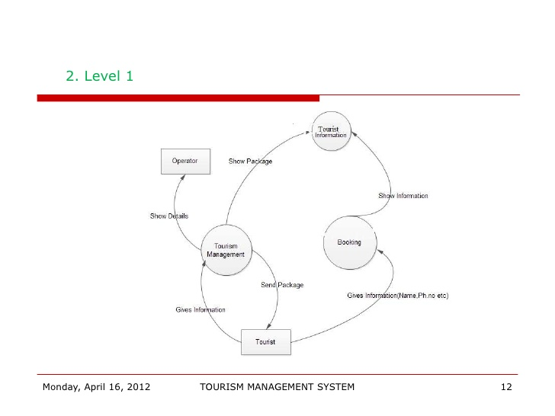

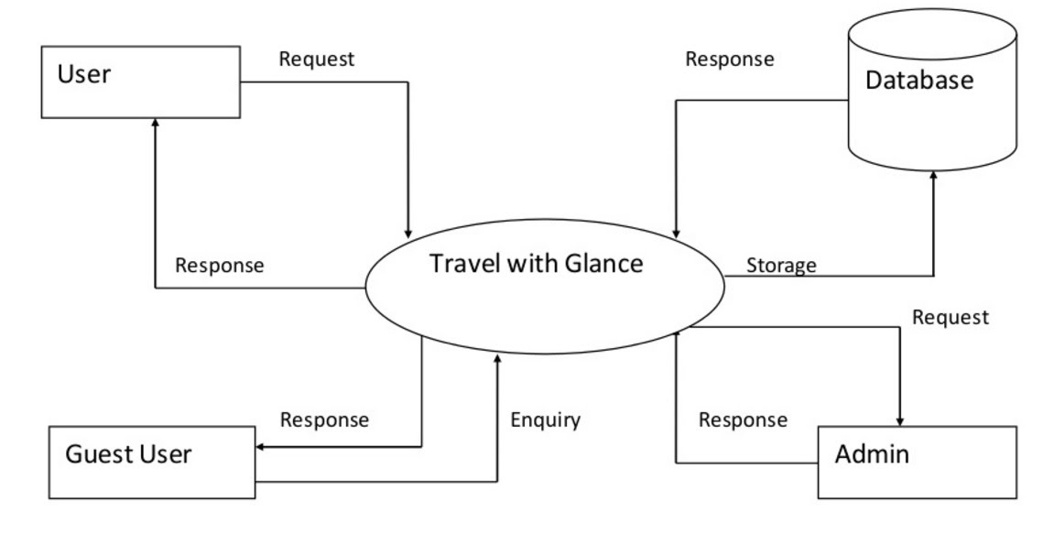

1. **Problem Analysis**

# 4.1.Product definition

# 4.1.1Administration

In this module the admin is the only person who has all the privileges to view the requesters documents in-order to proceed for the next-step because of this privilege genuine applications would be accepted. Admin is also responsible for transfer of amount to the applicants in case of any financial request. Admin can add end-user’s details to the system.

# 4.1.2User

The Requesters and donor’s details are stored in MYSQL database. User can view their profile picture, name and E-mail address so that they will be able to know with which account they have been logged in.

# 4.1.3User Interface

* The system will allow the user to create account in tourism site
* The system will allow the user to add the package in wishlist.
* The system will allow the user to add in cart.
* The system will allow to book their plan.
* The system will allow to make plan and travel.
* The system will allow user to ask any questions through admin.

# User Account:

* Name
* E-mail id
* Mobile number
* Password
* Re-type Password

# User Role:

* Login
* Cart
* Booking
* Trip plan

# Admin roll:

* Manage users requests
* Manage all supporting information
* Manage admin portal about users

# 4.2.Feasibility report

Preliminary investigation examines project feasibility, the likelihood the system will be useful to the organization. The main objective of the feasibility study is to test the Technical, Operational and Economical feasibility for adding new modules and debugging old running system. All systems are feasible if they are given unlimited resources and infinite time. There are aspects in the feasibility study portion of the preliminary investigation. practicability study is meant to be the preliminary review of the facts to ascertain if it's merit continuing to the analysis section. From the angle of the analyst, the practicability analysis could be a primary tool for evaluating whether to proceed to the ensuing level or to discontinue the merchandise.

The key thought in practicability analysis is:

1. Technical Feasibility
2. Behavioral Feasibility
3. Operational Feasibility
4. Economic Feasibility

# 4.2.1.Technical Feasibility:

The system is compatible with several Browsers and resolutions. The technical desires of the system may include:

1.We have used MYSQL in creating database.

2.We have used HTML Scripting Language for development of the system.

3.We have used CSS for styling the interface of the system.

4. We tend to study that beneath that circumstances our project can offer output and beneath that circumstances, it doesn't.

5. We studied that under which circumstances our project will give output and under which circumstances it does not.

6. We studied the language and tools used to develop the project are reliable or not.

7. We have used Django as Framework for this system and python as primary language for backend whereas for front-end we have used HTML, CSS, React and Bootstrap.

8.We have MYSQL as Database. For managing images and files we have used pillow package.

9. We studied whether our product will be useful for the intended audience in any way or not.

The technical issue usually raised during the feasibility stage of the investigation includes the following

• Does the necessary technology exist to do what is suggested?

-NO

• Do the proposed equipments have the technical capacity to hold the data required to use the new system?

-YES

• Will the proposed system provide adequate response to inquiries, regardless of the number or location of users?

-YES

. Can the system be upgraded if developed?

-YES

# 4.2.2.Behavioral Feasibility:

As it is simple to access completely different options in numerous modules, users can act completely to this project. it'll be simply acceptable by the user as all the modules in our system provide some graphical user interface surroundings that create it user-friendly.

# 4.2.3.Operational Feasibility:

Proposed comes area unit helpful if they’ll be clad into data system i.e. it ought to profit the involved mass of individuals WHO tends to use it. which will meet the organizations operative needs. Operational practicability aspects of the project area unit to be taken as a very important part of the project implementation. a number of the necessary problems raise are to check the operational practicability of a project includes the following:

• Is there sufficient support for the management from the users?

-yes

• Will the system be used and work properly if it is being developed and implemented?

-yes

• Will there be any resistance from the user that will undermine the possible application benefits?

This system is targeted to be in accordance with the above-mentioned issues. Beforehand, the management issues and user requirements have been taken into consideration. So there is no question of resistance from the users that can undermine the possible application benefits

# 4.2.4.ECONOMIC FEASIBILITY:

A system can be developed technically and that will be used if installed must still be a good investment for the organization. In the economical feasibility, the development cost in creating the system is evaluated against the ultimate benefit derived from the new systems. Financial benefits is equal or exceed the costs. The system is economically feasible. It does not require any additional hardware or software.

**4.3.Project plan;**

A project plan is produced as management activities commence. The plan defines the process and tasks to be conducted, the people who will do the work, and the mechanisms for assessing risks, controlling change, and evaluating quality.

To develop this project, we follow Evolution Model. In which our requirements can change during development only.

# Development Schedule:

We set our schedule according to hours. As we spend daily few hours on project only. We got less than 35 days to complete it. Our schedule is as follow:

1. Feasibility Study -------------------------------------------4 days

2. Requirement Analysis--------------------------------------2 days

3. Design and Implementation-------------------------------4 days

4. Admin Interface---------------------------------------------3 days

5. User Interface-----------------------------------------------3 days

6. Database -----------------------------------------------------3 days

7. Login Interface---------------------------------------------3 days

8. Sign Up Interface-------------------------------------------2 days

9. Testing ------------------------------------------------------5 days

1. **Software Requirement Analysis**

# 5.1.Introduction

Requirement analysis is essential to the success of the system or any application or any web site. the wants should be measurable, documented, tested and will be associated with desires of every kind of users and will be satisfying style. Any application developed are having a vision and mission to serve the user with efficiency, effectively, properly, responsively and user friendly. thus, for the event of Crowd Funding System, first we tend to know what users predict from us.

**5.2.Specific Requirements**

**1. HTML and CSS:**

Hypertext Markup Language (HTML) is that the commonplace terminology for documents designed to be displayed in a very applications programmer. It may be aided by technologies such as Cascading Style Sheets (CSS) and Scripting languages such as Java script.

HTML contains elements, these can be used to wrap or enclose various components of the content in order to make it visible in a certain manner or act a particular way. The enclosing tags make an image or a word hyperlink to somewhere else. They can change the styles of the words and even make the font size bigger or smaller, etc.

Cascading Style Sheets (CSS) is a stylesheet language. It is used to show the presentation of a document that is written in XML or HTML. CSS shows how elements should be reflected on paper, in speech, on-screen, or on any other media.

**2.Visual studio:**

is an integrated development environment (IDE) from Microsoft. It is used to develop computer programs, as well as websites, web apps, web services and mobile apps. Visual Studio uses Microsoft software development platforms such as Windows API, Windows Forms, Windows Presentation Foundation, Windows Store and Microsoft Silverlight. It can produce both native code and managed code. Visual Studio supports 36 different programming languages and allows the code editor and debugger to support (to varying degrees) nearly any programming language, provided a language-specific service exists. Built-in languages include C, C++, C++/CLI, Visual Basic .NET, C#, JavaScript, TypeScript, XML, XSLT, HTML, and CSS. Support for other languages such as Python, Node.js, and among others.The most basic edition of Visual Studio, the Community edition, is available free of charge. The slogan for Visual Studio Community edition is "Free, fully-featured IDE for students, open-source and individual developers".

Visual Studio also includes a web-site editor and designer that allows web pages to be authored by dragging and dropping widgets. It is used for developing ASP.NET applications and supports HTML, CSS and JavaScript. It uses a code-behind model to link with ASP.NET code. From Visual Studio 2008 onwards, the layout engine used by the web designer is shared with the discontinued Expression Web. There is also ASP.NET MVC support for MVC technology as a separate download and ASP.NET Dynamic Data project available from Microsoft.

**2.Django:**

Django is often used to build almost any sort of website from content management systems and wikis, through to social networks and news sites. It can work with any client-side framework and may deliver content in almost any format (including HTML, JSON, XML, RSS feeds, etc.).

Django framework is a compact Python framework used for quick development in rapidly paced environments that function well with relational databases.

Django is Model View Controller style. It has a high-level, opensource bunch of libraries programmed in Python. Django is one of the most reputed server-side web frameworks. Similar to Python, it focuses on inefficiency. This leads to giving the developer an option to do almost all tasks with as little coding effort as possible. Django is scalable, mature, and fast with a number of communities of the developer. It is a robust set of built-in components. Django can access or create XML or JSON data instances and deal with out-of-the-box with relational database management systems such as PostgreSQL, MySQL, Oracle and SQLite.

**4.MySQL:**

MySQL is one of the most renowned open-source databases in the world. It has efficient performance, and it is user-friendly. It is also very much reliable. MySQL serves as the top database choice for web apps. It covers the entire range of websites and other personal projects through information services and the digital market. Many of the renowned applications such as Facebook, Twitter, YouTube, Yahoo! use MySQL. By using languages like PHP or Perl, we can create websites. Those websites will interact in real-time with a MySQL database.

**5.Javascript:**

JavaScript is a text-based programming language. It can be used on the client-side as well as the server-side. This helps you to achieve interaction between the web pages. Languages such as HTML and CSS provide structure and style to web pages. JavaScript provides the web pages interactive elements. A few of the examples of JavaScript which can be used every day are the search box on Flipkart or refreshing your Instagram feed. JavaScript enhances the user experience as it converts the static web page into an interactive page. In simple words, JavaScript adds behavior to web pages.

# 5.3.Software Requirements:

* Operating system: Windows 8/10
* Application: :Python using django, Asp.net
* Database: SQL server
* Software: Internet Explorer/Google chrome

# 5.4.Hardware requirements:

* Processor: Pererably 1.0 GHz or Greater.
* RAM: 1GB or greater.

**6.Design**:

Design is defined as a multistage process that mainly focus on transforming the user requirements into some required structure.

The design process translates the requirements into a representation of the software that can be accessed for quality product before code generation begins. It is the most creative and challenging stage of the SDLC (Software Development Life Cycle). It refers to the technical specifications that will be applied to the system.

This project is developed for a tourism manager where he is able to add new tourists, update/delete the tourist details.

This Web used to book their own plans and also can plan their plans through our web site and can select packages to travel around the world. Users can add their travel and can plan their destination.

Users are provided with login details through that they can check their process. Architecture Design Outline Of The Project The whole software design can be divided mainly into 3 parts - WebUI, a middleware layer and a persistence layer.

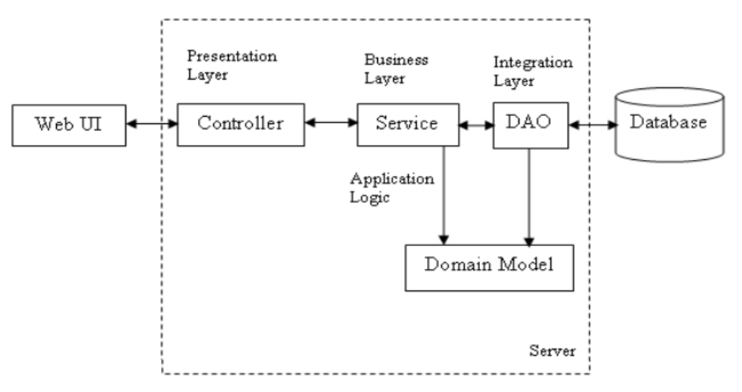

**Relational Database Schema**

The data is stored in a database that is developed in MySQL. The database consists of two tables. Data of a tourist means details such as ID, name, from location, to location, no. of days and the price of tour package with ID as the primary key which is placed in a table tourpackage.

* In our project we used python django as a backend
* Front end is mainly used for the designing purpose or designing the various kind of forms and implement the logic and the backend is mainly used for,to store the data records,or the information.
* The user portal has the data like username and password for login that enables the admin to manipulate the information regarding each tourist.

# 6.1Functional Requirement

# 6.1.1.User Management:

* User Registration:

The system allows the user to create an account. He can access the system using those credentials only.

* User Authentication:

User Authentication is done using the credentials using while registering in the system.

* User Login:

User can login and logout his account.

User can exit the application.

# 6.1.2.Profile Management:

The profile of the users contains the following:

* + First Name
  + Last Name
  + Phone Number
  + Email

# 6.1.3.User Profile Modification:

* User can change his email number and phone number.

**6.1.4. User profiles deletion:**

User can deactivate his account.

Design goals basically describe the qualities of the system that developers should keep in mind. Such goals are normally derived from the non-functional requirements of the system. They are:

● Performance

● Scalability

● Extensibility

● Integration

● Security

● Maintainability

**Performance:**

The application performance should be optimized, and response time should be minimized.

**Scalability:**

The application should be highly scalable; since it is meant to be used by people.

**Extensibility:**

The application should be extensible to allow adding other services in the future,. Also, allowing integration with APIs for chatbot and Rest API client.

**Integration:**

The system should have the ability to extend its requirements. For example, having the ability to extend with the minimum development and deployment costs.

**Security:**

The system should be highly secure using cloud functions since only authenticated users can have access to the server. It should respect the 3 aspects:

* Confidentiality:

The User shall ensure who gets to see their information.

* Integrity:

Editing data shall be authorized only to owners of the accounts

• Availability:

The application shall be available at all times.

**Maintainability:**

The system should be easily maintainable to allow for additional upgrades that can be implemented in the future.

**8.Project Implementation**

**8.1 Introduction**

Project implementation (or project execution) is the stage where vision and plans become reality. This is the obvious end result, subsequent to evaluating, deciding, visioning, planning, applying for assets and tracking down the financial resources of a project

Implementation basically implies doing the activities depicted in your work plan. We execute this project with various technologies like html,css ,Django. It requires the coordination of a wide scope of activities, the regulating of a team, the administration of tourist planning, the communication to the public, among different issues. Autonomous of whether it is a social project to raise the awareness and advance information about role of internt and online websites for tourism and , there is a sure interaction that must be followed. The accompanying lines will give you an introduction into the execution of projects in sustainable The growth of interest in this area is evident by the fact that the theme of e-metrics or website evaluations has appeared in ENTER proceedings since 2004. Prior to that time, publications in the area were often grouped into the themes of marketing or success factors for tourism website. The introduction of a special issue on website evaluations in IT&T at a later time further hints of the increasing demand for research in the area. Despite different approaches being used in the papers analyzed in this study, there were some similarities among these papers such as content analysis and questionnaire s, and features key perspectives that must be considered for a fruitful implementation

The implementation of Role of Information Technology in Tourism project is intricate. Since the project manages information about tourist places all over the world the. Technically it requires information about travelling facilties ,hotel arrangements for each tourist place..

Project Implementation phase involves:

i) Project Activation ii) Project Operation

This implies making arrangements to have the project begun. So every one of the prerequisites required for making the software helpful and address every one of the issues of the clients was accumulated by having sittings with them. The possibility study was made about the project that whether the project requested.by the client was feasible to execute or not. At that point, likewise the language or the stage that was required for the improvement of the project was chosen so the least complex, secure, robust platform ought to be chosen so everything necessary by the clients can be carried out by the developers without any problem.

**8.2 Key aspects for project implementation**

• Putting the action plan into operation.

• Achieving improvement and tangible changes.

• Ensuring that provide upadated information,safety measurementsand new resources are sustainable in every aspect.

• Ensuring that all the unforeseen conflicts that might arise during this stage are resolved.

• Ensuring transparency with respect to finances.

• Ensuring that provide all facilties with low cost.

**8.3 Conversion Plan**

**8.3.1 Overview:**

The Conversion Plan depicts the techniques engaged with changing data from an existing softeare over to another software or hardware environment. It is appropriate to reevaluate the original system's functional prerequisites for the state of the system before change to decide whether the original requirements are still valid. A blueprint of the Conversion Plan is shown below.

**8.3.2 Type of Conversion:**

This segment depicts the kind of coversion effects. The software part of the transformation exertion typically can be categorized as one of the accompanying classifications:

Intra language change is a transformation between different versions of a similar computer language or various renditions of a software system, for example, a database management system (DBMS), operating system, or local area network(LAN) management system.

• Inter language transformation is the change from one computer language then onto the next or starting with one software system to another.

• Same compiler transformations utilize similar language and compiler versions. Regularly, these transformations are performed to make programs conform to norms, improve program performance, convert to a new system concept, and so on These transformations may require some program upgrade and for the most part require some reprogramming.

Notwithstanding the three classifications of transformations portrayed above, different types of changes might be defined as essential

**8.3.3 Conversion Strategy**

This section describes the conversion of system hardware, software, and data stratergies:-

1. Hardware Conversion Strategy:

This part depicts the technique to be utilized for the conversion of the system hardware, assuming any. Portray the new (target) hardware environment, if appropriate.

2. Software Conversion Strategy:

This part depicts the conversion technique to be utilized for software.

3. Information Conversion Strategy:

This segment portrays the information change system, information quality confirmation, and the information transformation controls.

4. Data Conversion Approach:

This part depicts the particular data readiness prerequisites and the data that should be accessible for the system conversion. In the event that data transported from the original system, give a detailed depiction of the data handling with, change, and stacking procedures. In the event that this data will be moved to utilize machine-readable media, describe the attributes of those media.

5. Interfaces:

On account of a hardware platform transformation like mainframe to client/server - the interfaces to different systems may require reengineering. This part depicts the influenced interfaces and the updates needed in each.

6. Data Quality Assurance and Control:

This segment depicts the procedure to be utilized to guarantee data quality when all data changes. This part additionally depicts the way to deal with data cleaning and quality evaluation of data before they are moved to the new or converted system. The procedure and approach might be depicted in a conventional transition plan or a record if more appropriate.

7. Conversion Risk Factors:

This part portrays the significant risk factors in the transformation exertion and stratergies for their control or decrease. Portrayals of the risk factors that could influence the transformation attainability, the technical performance of the changed system, the transformation schedule, or expenses ought to be incorporated. Moreover, an audit ought to be made to guarantee that the current backup and recovery procedures are sufficient just as operational.

**8.3.4 Conversion Tasks**

This segment depicts the significant errands related with the change, including arranging and pre-transformation undertakings.

**1. Conversion Planning:**

This part depicts anticipating the conversion effort. In the event that planning and related issues have been tended to in other life-cycle records, reference those reports in this segment. The accompanying list gives a few instances of change planning issues that could be addressed:

• Analysis of the responsibility projected for the objective change environment to guarantee that the projected environment can sufficiently deal with that responsibility and meet capacity requirements and performance.

• Growth rate projection of the data preparing needs in the objective environment to guarantee that the system can deal with the projected close term development, and that it has the expansion capacity with respect to future requirements

• Analysis to recognize missing features in the new (target) hardware and software environment that were upheld in the original hardware and software and utilized in original system.

• Development of a strategy for reprograming, recoding or redesigning the components of the system that used software and hardware features not supported in the new (target) software and hardwareware environment but used in the original system

**2. Pre-Conversion Tasks:**

This part depicts all tasks that are logically independent from the transformation effort itself however that should be finished before the initiation, development, or consummation of the conversion effort. Instances of such pre-transformation errands include:

• Finalize choices in regards to the sort of conversion to be pursued.

• Install changes to the system hardware, like another communication hardware or computer, if required.

• Implement changes to operating system components or computer operating system for example, the installation of a new windowing system or a new LAN operating system.

**8.3.5 Security: -**

If appropriate for the system to be carried out, give an outline of the system security features and the security during transformation.

1. System Security Features:

The depiction of the system security features, whenever gave, ought to contain a concise overview and conversation of the security includes that will be related with the system when it is changed over. Reference other life-cycle documentss as proper. Depict the progressions in the security features or execution of the system that would result from the transformation.

2. Security During Conversion:

This section addresses security issues explicitly identified with the conversion effort.

**8.3.6 Conversion Support**

This part portrays the support required to execute the system. In the event that there are extra support requirements not covered by the classifications appeared here, add different subsections on a case by case basis.

1. Hardware: This part records support equipments, including all hardware to be utilized for the transformation.

2. Programming: This segment records the software and data bases needed to help the change. It depicts all software tools used to help the change effort, including the accompanying kinds of software tools, if used:

3. Automated conversion tools, for example, software translation tools for translating among various computer languages or interpreting inside software families, (for example, between discharge versions of compilers and DBMSs)

4. Automated data conversion tools for translating among data storage formats associated with the different implementations (such as, different DBMSs or operating systems)

5.Quality assurance and validation software for the data conversion that are automated testing tool

6. Computer helped software engineering (CASE) instruments for reverse engineering of the current application

7. CASE devices for capturing system design information and introducing it graphically

Documentation tools, for example, cross-reference records and data attributes generators

8. Commercial off-the-shelf software and software written specifically for the conversion effort

9. Facilities: This section identifies the physical facilities and accommodations required during the conversion period

10. Materials: This section lists support materials.

**8.4 Post-Implementation and Software Maintenance:**

**8.4.1 Post-Implementation**

1. After the system is implemented and, a review should be conducted to determine whether the system is meeting the required expectations and where improvements are needed.

2. A post implementation review measures the systems performance against pre-defined requirements of the system. It determines how well the system will continue to work to meet performance specifications.

3. A post Implementation review is also defined as an system evalution with respect to the degree to which the system achieves expressed goals and roles and genuine project costs surpass initial estimation. It is typically a survey of major issues that needs conversion and those that surfaced during the implementation phase

4. The post implementation study begins with the review team, which collects and reviews requests for evaluation. change which are unexpected in the system that affects the user or system performance is a concern factor that prompts system review. Once request is filed, The user is asked to check how well the system is functioning to specifications or how well the measured benefits have been realized. Suggestions regarding improvements and changes are also welcomed.

**8.4.2 Software Maintenance:**

In Web Application maintenance we have to check that whether the application have their correct working or not. It is used to improve performance of the software and provide better results. It is concerned with modifying application once it is delivered to the users or we can say that the process of modifying the software or components after delivery to correct faults, improve performance or other attributes, or adapt to a change in the environment and provide better results. There are four categories of Web Application maintenance these are:

1. Perfective maintenance: changes required as a result of user request

2. Adaptive maintenance: changes needed as consequence of operating system, hardware

3. Corrective maintenance: changes needed after the identification and removal of faults in the software.

4. Preventative maintenance: changes made before to software to make it more maintainable

**9. Project Legacy**

**9.1 Current Status of the Project**

1. We developed interfaces for The role of information technology in Tourism application using python, Libraries, Html, CSS etc.

2. For the web application we developed using HTML, CSS, django etc.

3. In this Tourism project the user can get information about all tourism places and they can able to register directly in this website for desired places.

4. We provided feed so that users can see the feed by different levels like emergency and etc.

5. Users can use our project in any android platform and many compatible browsers.

6. Currently our application was connected with firebase where the user information is saved.

7. Webpage is connected with localhost using XAMMP server.

**9.2 Remaining Areas of Concern**

1. For Admin Panel, we can connect to the Firebase to store and update the data given by the users.

2. For User Panel, we provided feed where they can get all details and for registration.

3. For User Panel, we provided document upload where we verify the details and upload so they can get the confirmation details .

**9.3 Technical and Managerial Lessons Learned**

**9.2.1 Technical**

**Web Page:**

1. Bootstrap

2. HTML

3. CSS

4. DJANGO

5. MYSQL

Here are some interface pictures of our website

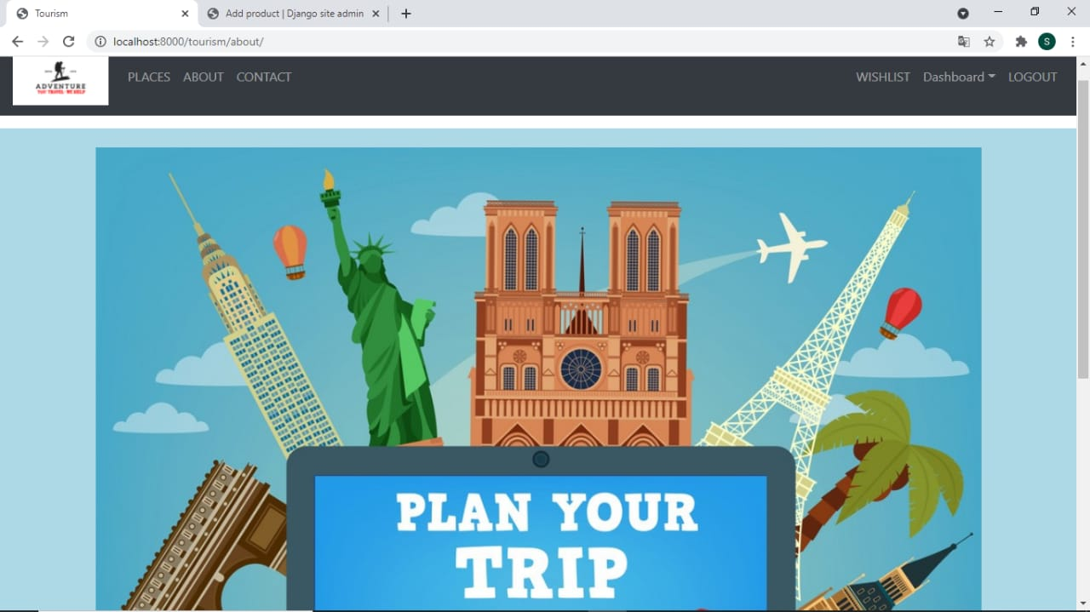

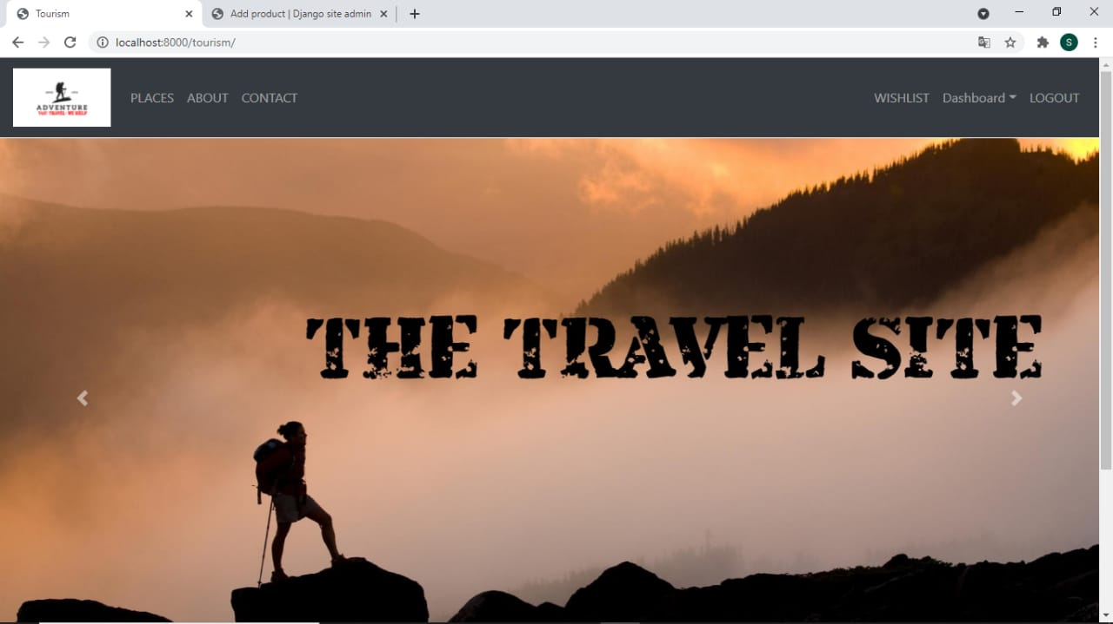

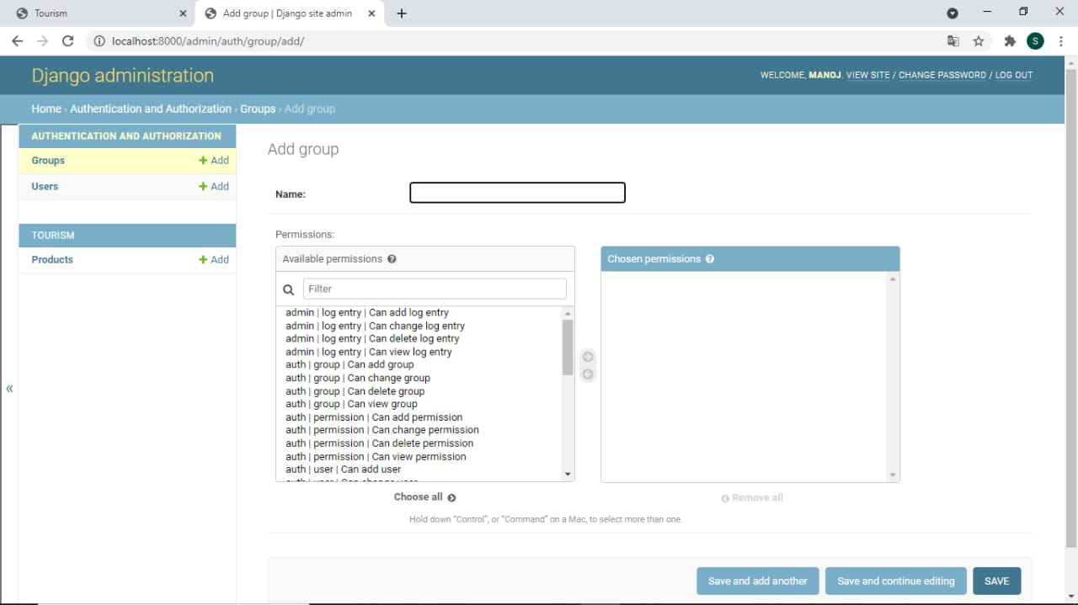

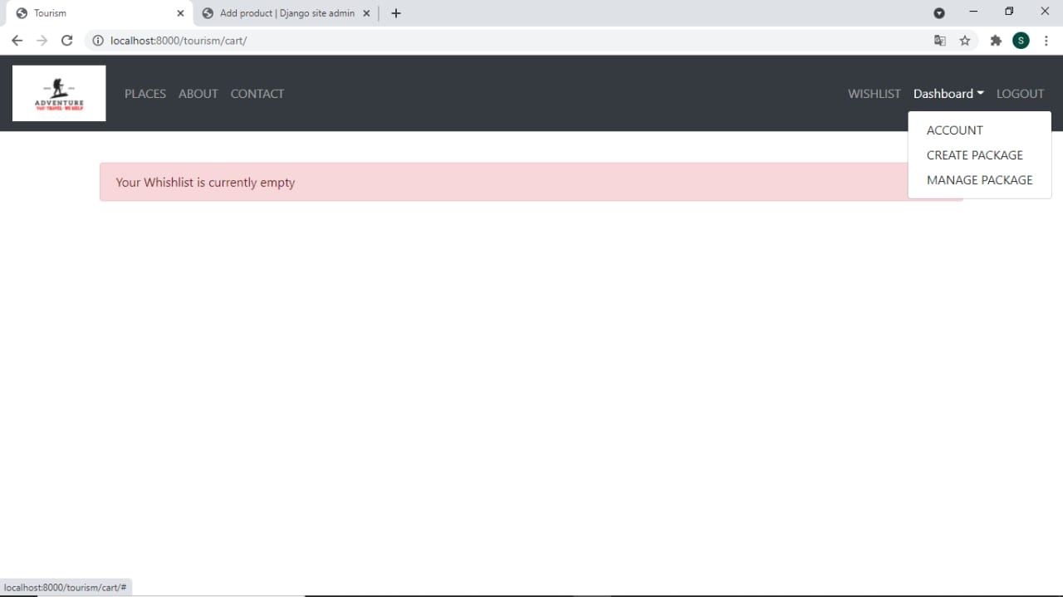 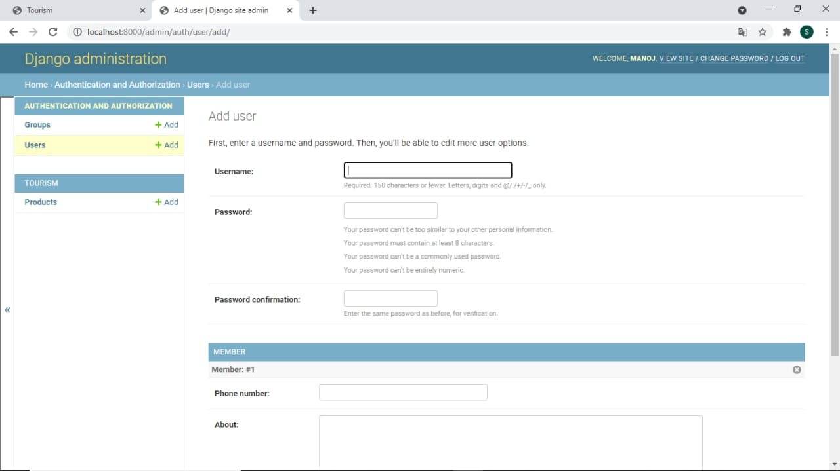

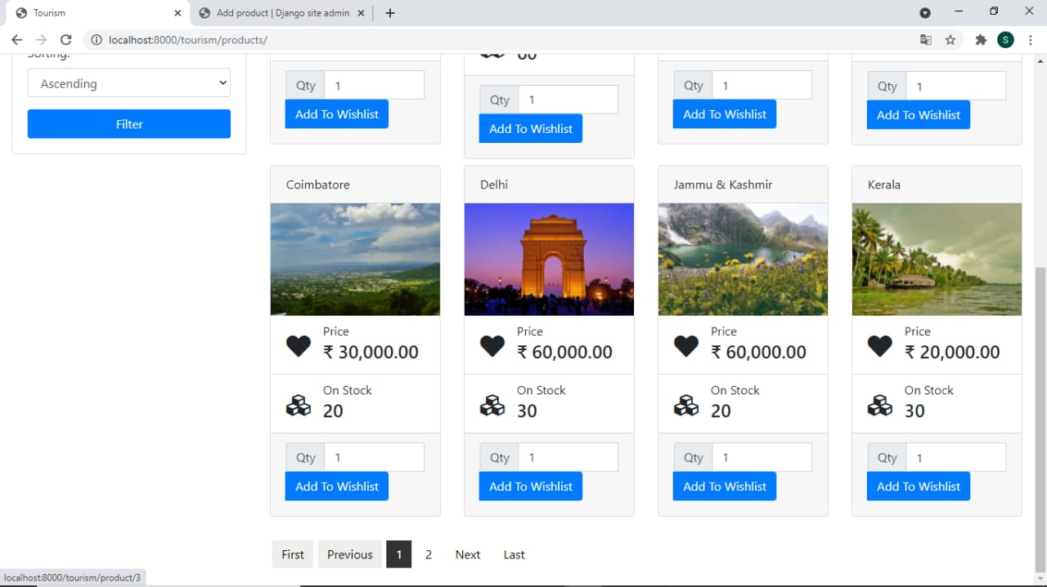

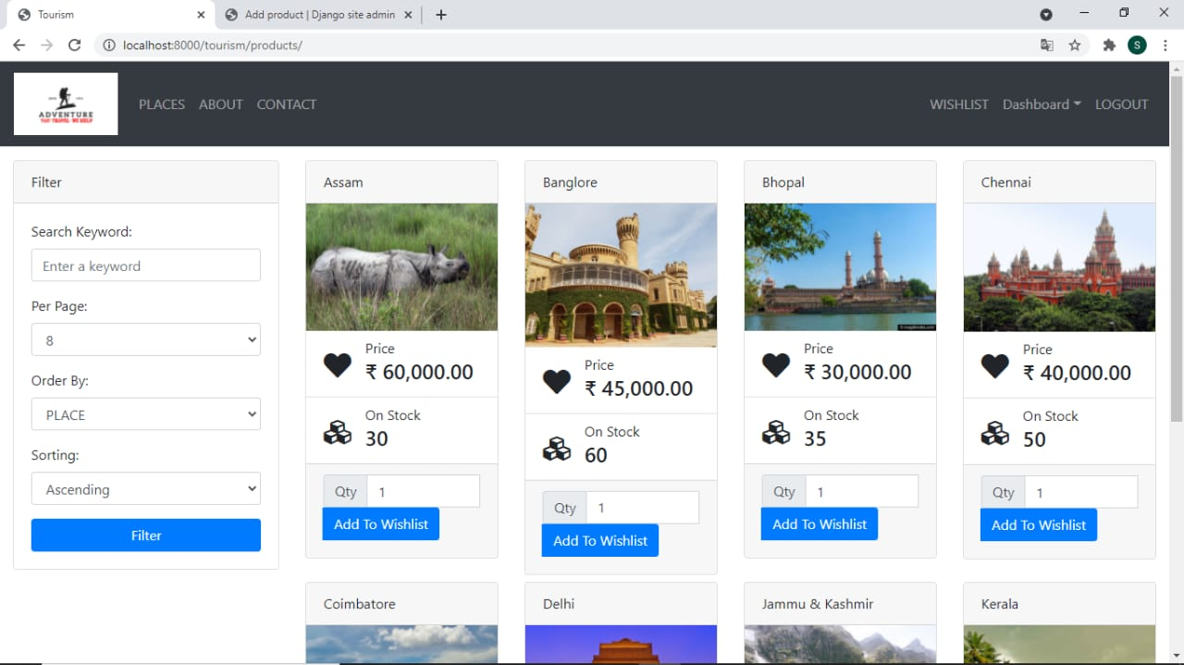

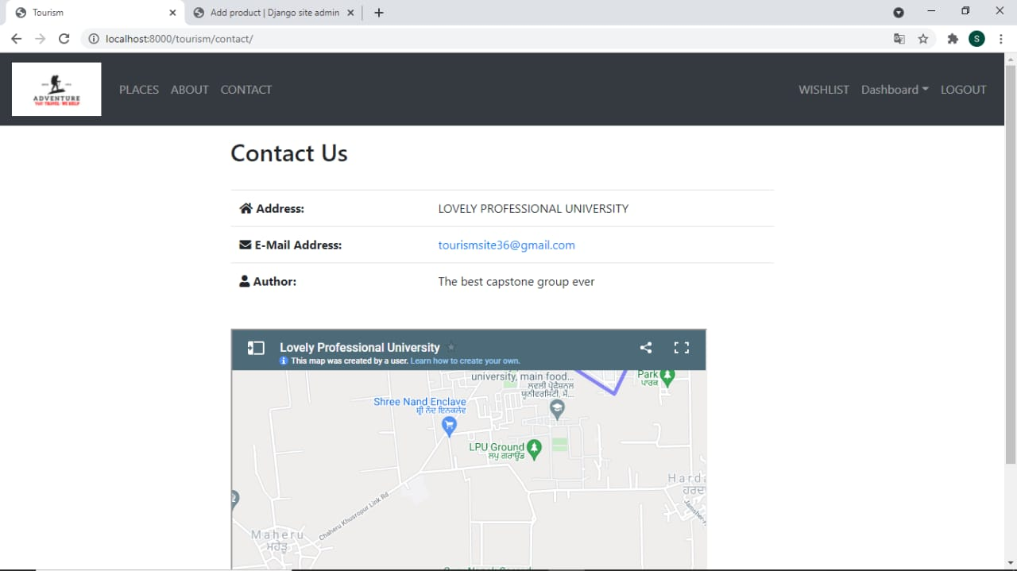

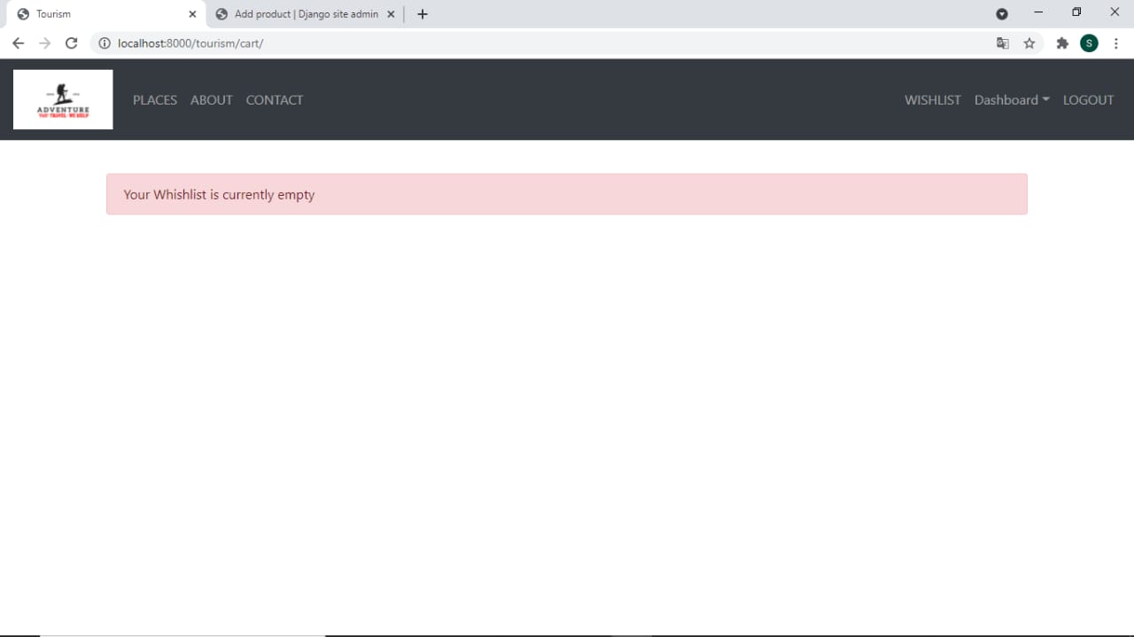

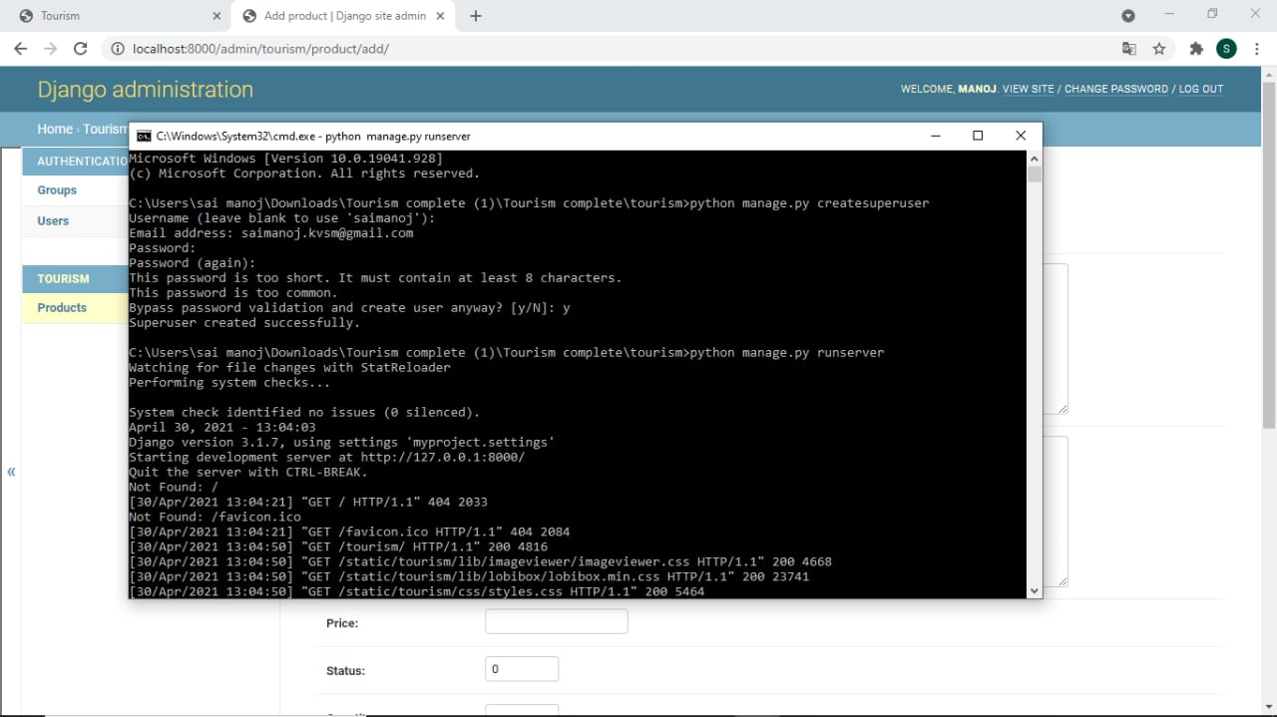

**Managerial:**

1. Learned Team Management.

2. Learned how to divide and distribute among ourselves to complete project in given time. 3. Learned how to deal with situations when stuck or face problems. 4. Learned how to work with group of developers and designers. 5. Learned to distribute tasks to team members. 6. Learned about the leadership quality. 7. Learned about the software skills that must be present in an each and every individual.

**Project advantages**

* An all-inclusive travel management application
* Built on an advanced and scalable technology
* Flexible and easy to use
* Easy to customize as per clients’ need.
* Efficient client management featuring the complete details of clients’ queries
* Highly secured back office system
* Helps to establish brand loyalty
* Curtail significant capital expenses and improve ROI
* Dedicated customer support from experts
* **PROPOSED SYSTEM**
* The proposed system is designed to be more efficient than the manual system. It invokes all base tasks that are now carried out manually, such as the forms transactions and reports which is added advantage. The proposed System is completely computer-based application. Thousands of records can searched and displayed without taking any significant time Advantages of the Proposed System:
* Gives accurate information
* Simplifies the manual work
* It minimizes the documentation related work
* Provides up to date information
* Friendly Environment by providing warning messages.
* travelers details can be provided

**End user**

This project is designed to help travel agent, tour operator, Destination Management Company and travel agency to respond effectively to their customers’ requisites.

Integration with online booking technology, Online Travel Management Software is complete travel software solution deliver end-to-end solutions for Travel Reservation, Hotel Reservation, Operations.

The users have a intuitive UI and UX in this website and this makes the travelling experience seamless, providing information about the destination, best places to visit, best time to visit and some picturesque.

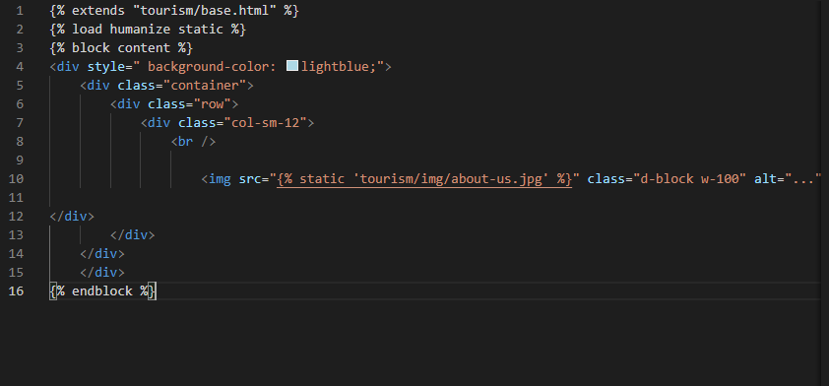Here are Some Snaps of our code:

